Lab 5 - IT21294570

EX.1

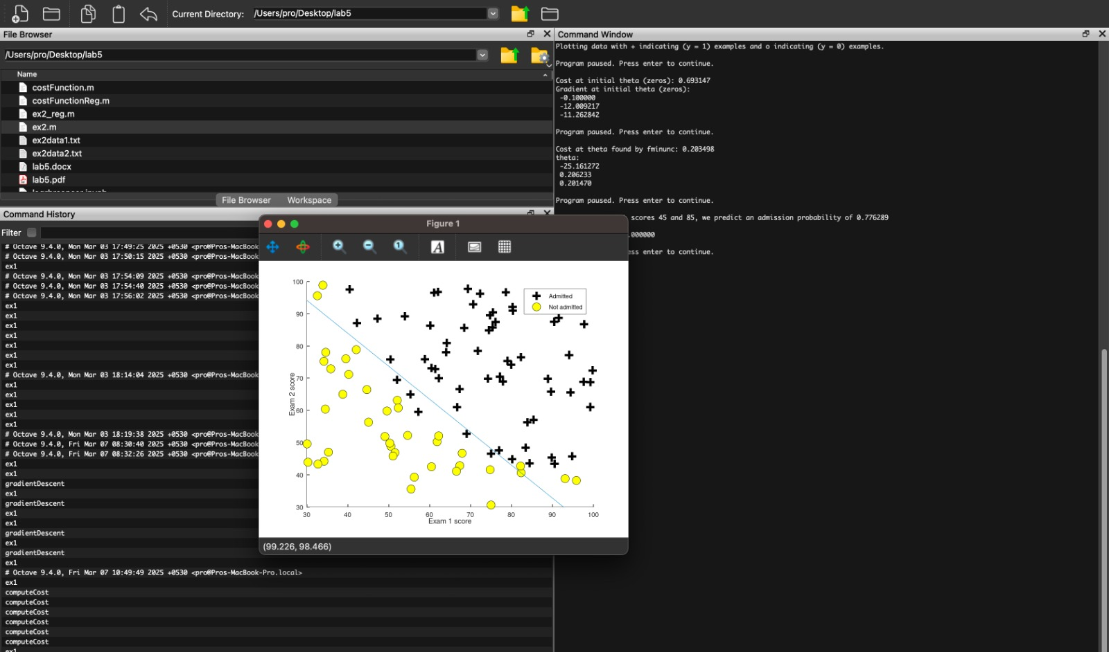

EX.2

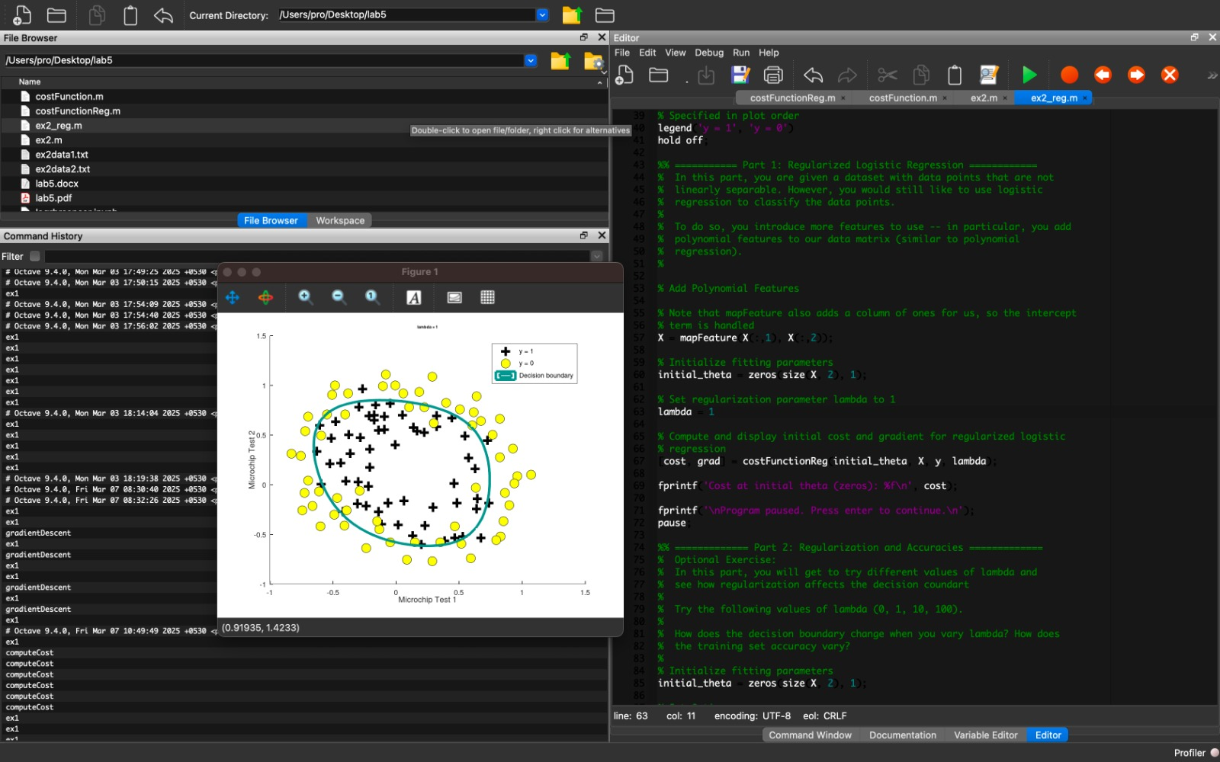

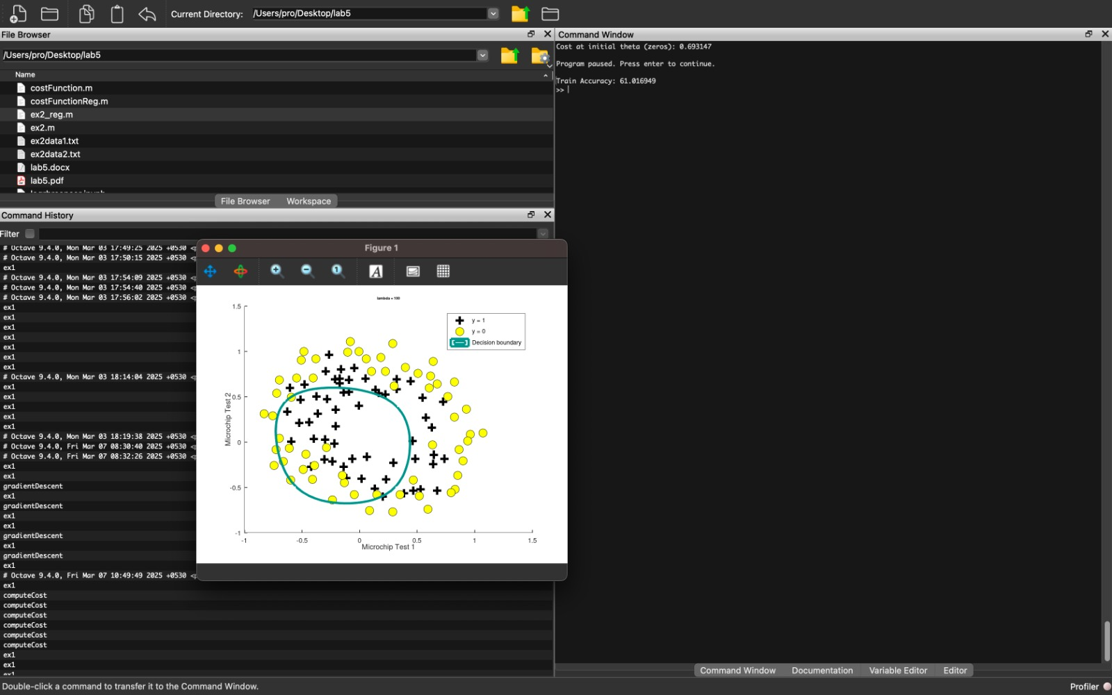

9. When Lambda increasing accuracy is low and may be underfit and when Lambda decreasing to a normal value like around 1 and 20 it has a high accuracy and generalized. When lambda is much lower it gives high accuracy but leads to overfitting.

12. C values represent the regularization strength. When value increases up to optimal it increased but after the optimal point it decreases gradually. So, in here optimal value is around 1 – 10. For a value like 5 it gives higher accuracy in both train and test.